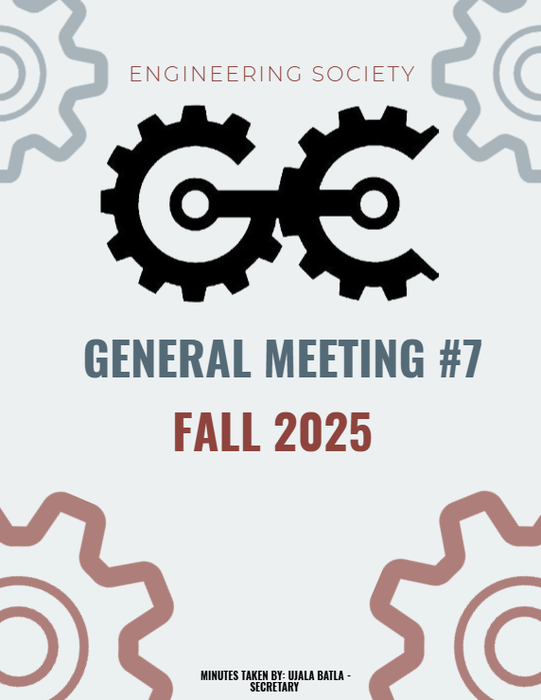

^{8th} GENERAL MEEETING
OCTOBER 27th ,2025, 6:00 PM
UNIVERSITY OF GUELPH, THRN 1365

ATTENDANCE
NAME | ROLE | PRESENT
PHILLIP MCMORRAN | PRESIDENT | Y
CHARLES KOSHMAN | CHAIR | Y
UJALA BATLA | SECRETARY (F) | Y
GUILIA CASTI | SECRETARY (W)
SABINE HAMZE | VP EXTERNAL | Y
JOSEPH HOWELL | VP ACADEMIC | Y
VERONICA LYNAS | VP SOCIAL | Y
SUSANNA PILCHAK | VP SOCIAL | Y
ABIGAIL JACKSON | VP COMMUNICATION | Y
ANDREA RODIN | VP EDI | Y
QUY AN NGO (WILL) | VP FINANCE | Y
LAINE YOUNG | 4TH YEAR ENVIRO/WATER REP | Y
SYDNEY YOTT | 4TH BIO/BIOMED REP | Y
NICHOLAS HUTZOL | THRN MANAGER | Y
KHANG NGUYEN | EEL MANAGER | Y
SALIM DA’AS | EEL MANAGER
HANA RAVE | MERCH COORDINATOR (F)
EMMA SANDERSON | MERCH COORDINATOR (W) | Y
OLIVIA JESSOP | ARTS OFFICER
MACY JOHNSTON | ATHLETICS COORDINATOR (F) | Y
HANNAH SMYTH-LIU | 4TH YEAR MECH REP
EMMA RENAUD | 4TH YEAR BIO/BIOMED REP (F) | Y
SOPHIA TOPERCZER | 3RD YEAR ENVIRO/WATER REP
OJASWIN AUJLA | 3RD YEAR BIO/BIOMED REP | Y
ELAINE XU | GEPD CO-PRES | Y
NIKITA UPADHYAY | GEPD CO-PRES
ERIC PFOHL | 2ND YEAR REP | Y
MAXIME MORIN | 2ND YEAR REP | Y
MAYA BARBERA | ATHLETICS COORDINATOR (W) | Y
MAYA MURGELAS | 1ST YEAR REP | Y
CELINE RUDOLPH | SPECIAL EVENTS COORDINATOR | Y
ANISH G. | SPECIAL EVENTS COORD | Y
HENRY TAIT | SUSTAINABILITY OFFICER (F)
VANESSA BRENDERS | SUSTAINABILITY OFFICER
LAUREN M. | MARKETING COORDINATOR (F) | Y
HERMAN SAINI | MARKETING COORDINATOR (W)
FRANKLIN G. | O-SNAP COORDINATOR
TARYNN KEARNEY | IT COORDINATOR | Y
 | COMP REPRESENTATIVE
URIEL MATAN MARKS-MAISTER | 3RD YEAR MECH REPRESENTATIVE | Y
ETHAN CARREON | TREASURER CG
MATTIGAN DILLABOUGH | PRODUCER CG
ABBY REDMOND | OWWA PRESIDENT
OWEN MACKENZIE | GNCTR CO-CAPTAIN
CARRYS FRANKLIN | GNCTR CO-CAPTAIN
SWAVA BANGALI | WISE
MARTINA BJURVAN | ESW
ANNA STERLING | ESW
STEVEN | IEEE
ELIJAH FERNANDES | IEEE / IT COORDINATOR
MOHAMMED AL-ODA | 1ST YEAR REP | Y
STEVE | 4TH YEAR REP | Y
BAS | INTERNATIONAL REP | Y

LAND ACKNOWLEDGEMENT GIVEN BY SUZI

INTRODUCTIONS
- Welcomed new faces to the meeting.
- Everyone introduced themselves, sharing their name, position, program and year, pronouns, and favorite cereal.

APPROVAL OF LAST WEEKS MEETING MINUTES
- Motion: To approve the minutes from last week’s meeting.
Moved by: Abby
Seconded by: Nick
Vote: Passed unanimously.

PDC TICKET SALES PRESENTATION
- Presenter: Elaine
- Provided an update on Professional Development Conference (PDC) ticket sales.
- PDC Overview:
  - Organized by engineering students, for engineering students.
  - Focus on learning, professional growth, and networking.
  - Includes free swag, resume and interview feedback, and sessions to build a personal brand.
  - Full-day event offering significant value — “bang for your buck.”
- Current Concern: Ticket sales are lower than expected.
- Planned Initiatives to Boost Sales:
  - Professors posting announcements on Courselink.
  - GEPD tabling in the atrium.
  - Distribution of business cards.
  - Sending email announcements to all students.
  - In-class announcements in engineering courses.
  - A coordinated social media push.
- Tickets available on the EngSoc Store and in the EngSoc Office.

DECEMBER 6TH MEMORIAL
- Presenter: Phil
- Shared updates on the National Day of Remembrance and Action on Violence Against Women (Dec 6th Memorial).
- In contact with main organizers, who are transitioning the event into a college-wide initiative rather than solely an EngSoc event.
- Request for rose bearers (traditionally women from EngSoc or WISE) to participate.
- Volunteers encouraged to sign up if interested.

GUELPH ENGINEERING COMPETITION
- Presenter: Abby
- GEC planning is progressing smoothly.
- Volunteers needed to help ensure events run efficiently.
  - Dates: November 15–16
- Sponsorship opportunities are open — external sponsors (e.g., co-op companies) are being sought.
- Uriel humorously suggested a hard seltzer company as a potential sponsor.

PARKING LOT ITEMS
- Elaine:
- Announced that GEPD will be hosting a Resume Workshop tomorrow.
- Students are encouraged to bring a hard copy of their resume.
- Free pizza will be provided for attendees.

MOTION TO ADJOURN: MOVED BY PHIL, SECONDED BY SABINE
PASSED UNANIMOUSLY
MEETING ADJOURNED

NAME | ROLE | APPROVED (Y/N)
PHILLIP MCMORRAN | PRESIDENT
CHARLES KOSHMAN | CHAIR
UJALA BATLA | SECRETARY (F)
GUILIA CASTI | SECRETARY (W) | Y
SABINE HAMZE | VP EXTERNAL | Y
JOSEPH HOWELL | VP ACADEMIC | Y
VERONICA LYNAS | VP SOCIAL | Y
SUSANNA PILCHAK | VP SOCIAL | Y
ABIGAIL JACKSON | VP COMMUNICATION | Y
ANDREA RODIN | VP EDI | Y
QUY AN NGO (WILL) | VP FINANCE
LAINE YOUNG | 4TH YEAR ENVIRO/WATER REP
SYDNEY YOTT | 4TH BIO/BIOMED REP
NICHOLAS HUTZOL | THRN MANAGER | Y
KHANG NGUYEN | EEL MANAGER
SALIM DA’AS | EEL MANAGER
HANA RAVE | MERCH COORDINATOR (F)
EMMA SANDERSON | MERCH COORDINATOR (W)
OLIVIA JESSOP | ARTS OFFICER
MACY JOHNSTON | ATHLETICS COORDINATOR (F) | Y
HANNAH SMYTH-LIU | 4TH YEAR MECH REP
EMMA RENAUD | 4TH YEAR BIO/BIOMED REP (F)
STEVEN SHELESTOWSKY | 4TH YEAR COMP/ES&C REP | Y
SOPHIA TOPERCZER | 3RD YEAR ENVIRO/WATER REP
OJASWIN AUJLA | 3RD YEAR BIO/BIOMED REP | Y
ELAINE XU | GEPD CO-PRES
NIKITA UPADHYAY | GEPD CO-PRES
ERIC PFOHL | 2ND YEAR REP | Y
MAXIME MORIN | 2ND YEAR REP | Y
MAYA BARBERA | ATHLETICS COORDINATOR (W) | Y
CELINE RUDOLPH | SPECIAL EVENTS COORDINATOR | Y
ANISH G. | SPECIAL EVENTS COORD | Y
SAMRATH SINGH | 3RD YEAR REP
VANESSA BRENDERS | SUSTAINABILITY OFFICER | Y
LAUREN M. | MARKETING COORDINATOR (F)
HERMAN SAINI | MARKETING COORDINATOR (W)
FRANKLIN G. | O-SNAP COORDINATOR
TARYNN KEARNEY | IT COMMISSIONER
 | COMP REPRESENTATIVE
URIEL MATAN | 3RD YEAR MECH REPRESENTATIVE
MAYA MURGELAS | 1ST YEAR REP | Y
Mohammed Al-Oda | 1ST YEAR REP
JON DON | FACULTY ADVISOR
ELIJAH FERNANDES | IT COORDINATOR

