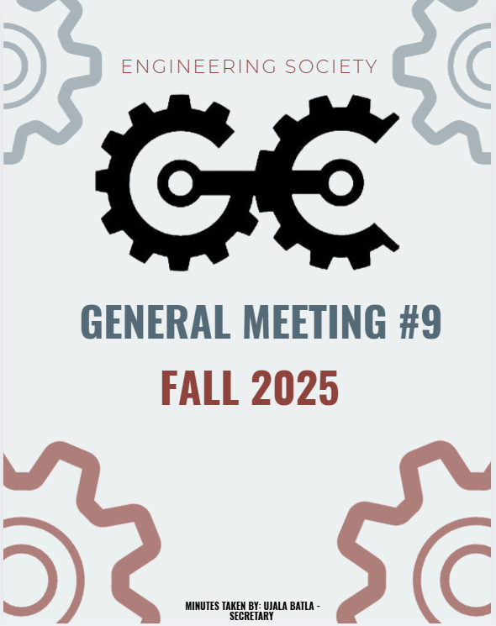

^{9th} GENERAL MEEETING
NOVEMBER 10th ,2025, 6:00 PM
UNIVERSITY OF GUELPH, THRN 1365

ATTENDANCE
NAME | ROLE | PRESENT
PHILLIP MCMORRAN | PRESIDENT | Y
CHARLES KOSHMAN | CHAIR | Y
UJALA BATLA | SECRETARY (F) | Y
GUILIA CASTI | SECRETARY (W)
SABINE HAMZE | VP EXTERNAL | Y
JOSEPH HOWELL | VP ACADEMIC | Y
VERONICA LYNAS | VP SOCIAL | Y
SUSANNA PILCHAK | VP SOCIAL | Y
ABIGAIL JACKSON | VP COMMUNICATION | Y
ANDREA RODIN | VP EDI | Y
QUY AN NGO (WILL) | VP FINANCE | . N
LAINE YOUNG | 4TH YEAR ENVIRO/WATER REP | Y
SYDNEY YOTT | 4TH BIO/BIOMED REP | Y
NICHOLAS HUTZOL | THRN MANAGER | Y
KHANG NGUYEN | EEL MANAGER | Y
SALIM DA’AS | EEL MANAGER
HANA RAVE | MERCH COORDINATOR (F)
EMMA SANDERSON | MERCH COORDINATOR (W) | Y
OLIVIA JESSOP | ARTS OFFICER
MACY JOHNSTON | ATHLETICS COORDINATOR (F) | Y
HANNAH SMYTH-LIU | 4TH YEAR MECH REP
EMMA RENAUD | 4TH YEAR BIO/BIOMED REP (F) | Y
SOPHIA TOPERCZER | 3RD YEAR ENVIRO/WATER REP
OJASWIN AUJLA | 3RD YEAR BIO/BIOMED REP | Y
ELAINE XU | GEPD CO-PRES | Y
NIKITA UPADHYAY | GEPD CO-PRES
ERIC PFOHL | 2ND YEAR REP | Y
MAXIME MORIN | 2ND YEAR REP | Y
MAYA BARBERA | ATHLETICS COORDINATOR (W) | Y
MAYA MURGELAS | 1ST YEAR REP | Y
CELINE RUDOLPH | SPECIAL EVENTS COORDINATOR | Y
ANISH G. | SPECIAL EVENTS COORD | Y
HENRY TAIT | SUSTAINABILITY OFFICER (F)
VANESSA BRENDERS | SUSTAINABILITY OFFICER
LAUREN M. | MARKETING COORDINATOR (F) | Y
HERMAN SAINI | MARKETING COORDINATOR (W)
FRANKLIN G. | O-SNAP COORDINATOR
TARYNN KEARNEY | IT COORDINATOR | Y
 | COMP REPRESENTATIVE
URIEL MATAN MARKS-MAISTER | 3RD YEAR MECH REPRESENTATIVE | Y
ETHAN CARREON | TREASURER CG
MATTIGAN DILLABOUGH | PRODUCER CG
ABBY REDMOND | OWWA PRESIDENT
OWEN MACKENZIE | GNCTR CO-CAPTAIN
CARRYS FRANKLIN | GNCTR CO-CAPTAIN
SWAVA BANGALI | WISE
MARTINA BJURVAN | ESW
ANNA STERLING | ESW
STEVEN | IEEE
ELIJAH FERNANDES | IEEE / IT COORDINATOR | Y
MOHAMMED AL-ODA | 1ST YEAR REP | Y
STEVE | 4TH YEAR REP | Y
BAS | INTERNATIONAL REP | Y

LAND ACKNOWLEDGEMENT GIVEN BY MAYA

APPROVAL OF LAST WEEKS MEETING MINUTES
- Motion: To approve last week’s meeting minutes.
Moved by: Phil
Seconded by: Abby
Vote: Passed unanimously.

MISSING OFFICE ITEM – NEXANS BACKPACK
- A Nexans backpack has gone missing from the EngSoc office.
- As a result, a temporary ban has been placed on non-EngSoc individuals entering the office.
- Phil emphasized that these security measures need to remain in place for the time being.

WINTER SOCIAL
- Presenter: Phil
- Date: December 26 at 6:30 PM
- Activities: Secret Santa exchange
- Dinner: Covered by EngSoc at Brass Taps
- Transition Reports:
  - Must be completed by the end of November.
  - Required in order to attend the Winter Social.

PARKING LOT
- Ronnie:
- Reminder about Ballin’ for a Cause, a Movember charity basketball event.
- Encourage friends and peers to attend.
- EngSoc members may join buses heading to Waterloo at 5 PM.
- Reminder to vote for Secret Santa preferences.
- Joe:
- Asked about the deadline to buy tickets for the Winter Social; Ronnie confirmed Thursday.
- Celine:
- There are only 100 Winter Social tickets available.
- Approximately 15 tickets sold so far — members should purchase ASAP.
- Andrea (online):
- Encouraged members to sign up for a land acknowledgement.
- Resources available upon request.
- If you've already done a land acknowledgement this semester, you are not required to do another.
- Nick:
- Reminder to send winter schedules to Guilia for office hours planning.
- Elaine:
- Remembrance Day Ceremony in the UC at 10:30 AM.
- Will continue with a walk to the War Memorial, ending around 11:15 AM.
- Guilia:
- Space in front of the printer has been cleared, but boxes are accumulating.
- Requested that members help tidy the area.
- Roni:
- Team bonding laser tag event has been rescheduled to December.

MOTION TO ADJOURN: MOVED BY PHIL, SECONDED BY JOE
PASSED UNANIMOUSLY
MEETING ADJOURNED

NAME | ROLE | APPROVED (Y/N)
PHILLIP MCMORRAN | PRESIDENT
CHARLES KOSHMAN | CHAIR
UJALA BATLA | SECRETARY (F)
GUILIA CASTI | SECRETARY (W)
SABINE HAMZE | VP EXTERNAL | Y
JOSEPH HOWELL | VP ACADEMIC | Y
VERONICA LYNAS | VP SOCIAL | Y
SUSANNA PILCHAK | VP SOCIAL | Y
ABIGAIL JACKSON | VP COMMUNICATION | Y
ANDREA RODIN | VP EDI | Y
QUY AN NGO (WILL) | VP FINANCE
LAINE YOUNG | 4TH YEAR ENVIRO/WATER REP
SYDNEY YOTT | 4TH BIO/BIOMED REP
NICHOLAS HUTZOL | THRN MANAGER | Y
KHANG NGUYEN | EEL MANAGER | Y
SALIM DA’AS | EEL MANAGER | Y
HANA RAVE | MERCH COORDINATOR (F)
EMMA SANDERSON | MERCH COORDINATOR (W)
OLIVIA JESSOP | ARTS OFFICER
MACY JOHNSTON | ATHLETICS COORDINATOR (F)
HANNAH SMYTH-LIU | 4TH YEAR MECH REP
EMMA RENAUD | 4TH YEAR BIO/BIOMED REP (F)
STEVEN SHELESTOWSKY | 4TH YEAR COMP/ES&C REP | Y
SOPHIA TOPERCZER | 3RD YEAR ENVIRO/WATER REP
OJASWIN AUJLA | 3RD YEAR BIO/BIOMED REP | Y
ELAINE XU | GEPD CO-PRES
NIKITA UPADHYAY | GEPD CO-PRES
ERIC PFOHL | 2ND YEAR REP | Y
MAXIME MORIN | 2ND YEAR REP | Y
MAYA BARBERA | ATHLETICS COORDINATOR (W)
CELINE RUDOLPH | SPECIAL EVENTS COORDINATOR | Y
ANISH G. | SPECIAL EVENTS COORD | Y
SAMRATH SINGH | 3RD YEAR REP
VANESSA BRENDERS | SUSTAINABILITY OFFICER | Y
LAUREN M. | MARKETING COORDINATOR (F) | Y
HERMAN SAINI | MARKETING COORDINATOR (W) | Y
FRANKLIN G. | O-SNAP COORDINATOR | Y
TARYNN KEARNEY | IT COMMISSIONER | Y
 | COMP REPRESENTATIVE
URIEL MATAN | 3RD YEAR MECH REPRESENTATIVE
MAYA MURGELAS | 1ST YEAR REP
Mohammed Al-Oda | 1ST YEAR REP | Y
JON DON | FACULTY ADVISOR
ELIJAH FERNANDES | IT COORDINATOR | Y

