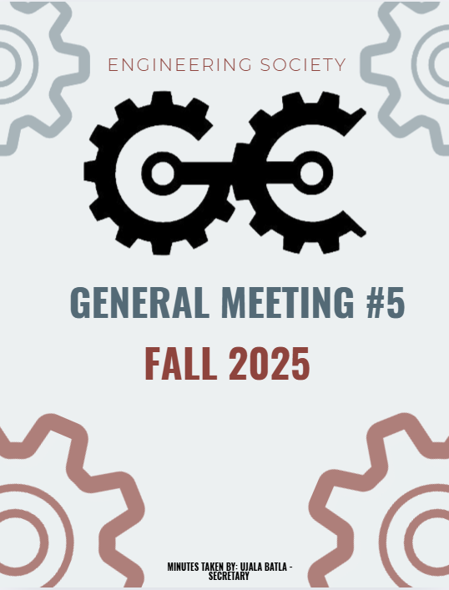
5th GENERAL MEEETING
OCTOBER 6th ,2025, 6:00 PM
UNIVERSITY OF GUELPH, THRN 1365

ATTENDANCE
NAME | ROLE | PRESENT
PHILLIP MCMORRAN | PRESIDENT | Y
CHARLES KOSHMAN | CHAIR | Y
UJALA BATLA | SECRETARY (F) | Y
GUILIA CASTI | SECRETARY (W)
SABINE HAMZE | VP EXTERNAL | Y
JOSEPH HOWELL | VP ACADEMIC | Y
VERONICA LYNAS | VP SOCIAL | Y
SUSANNA PILCHAK | VP SOCIAL | Y
ABIGAIL JACKSON | VP COMMUNICATION | Y
ANDREA RODIN | VP EDI | Y
QUY AN NGO (WILL) | VP FINANCE | Y
LAINE YOUNG | 4TH YEAR ENVIRO/WATER REP | Y
SYDNEY YOTT | 4TH BIO/BIOMED REP | Y
NICHOLAS HUTZOL | THRN MANAGER | Y
KHANG NGUYEN | EEL MANAGER | Y
SALIM DA’AS | EEL MANAGER
HANA RAVE | MERCH COORDINATOR (F)
EMMA SANDERSON | MERCH COORDINATOR (W) | Y
OLIVIA JESSOP | ARTS OFFICER
MACY JOHNSTON | ATHLETICS COORDINATOR (F) | Y
HANNAH SMYTH-LIU | 4TH YEAR MECH REP
EMMA RENAUD | 4TH YEAR BIO/BIOMED REP (F) | Y
SOPHIA TOPERCZER | 3RD YEAR ENVIRO/WATER REP
OJASWIN AUJLA | 3RD YEAR BIO/BIOMED REP | Y
ELAINE XU | GEPD CO-PRES | Y
NIKITA UPADHYAY | GEPD CO-PRES
ERIC PFOHL | 2ND YEAR REP | Y
MAXIME MORIN | 2ND YEAR REP | Y
MAYA BARBERA | ATHLETICS COORDINATOR (W) | Y
MAYA MURGELAS | 1ST YEAR REP | Y
CELINE RUDOLPH | SPECIAL EVENTS COORDINATOR | Y
ANISH G. | SPECIAL EVENTS COORD
HENRY TAIT | SUSTAINABILITY OFFICER (F)
VANESSA BRENDERS | SUSTAINABILITY OFFICER
LAUREN M. | MARKETING COORDINATOR (F) | Y
HERMAN SAINI | MARKETING COORDINATOR (W)
FRANKLIN G. | O-SNAP COORDINATOR
TARYNN KEARNEY | IT COORDINATOR | Y
 | COMP REPRESENTATIVE
URIEL MATAN MARKS-MAISTER | 3RD YEAR MECH REPRESENTATIVE | Y
ETHAN CARREON | TREASURER CG
MATTIGAN DILLABOUGH | PRODUCER CG
ABBY REDMOND | OWWA PRESIDENT
OWEN MACKENZIE | GNCTR CO-CAPTAIN
CARRYS FRANKLIN | GNCTR CO-CAPTAIN
SWAVA BANGALI | WISE
MARTINA BJURVAN | ESW
ANNA STERLING | ESW
STEVEN | IEEE
ELIJAH FERNANDES | IEEE
MOHAMMED AL-ODA | 1ST YEAR REP | Y
STEVE | 4TH YEAR REP | Y
BAS | INTERNATIONAL REP | Y

LAND ACKNOWLEDGEMENT GIVEN BY JOSEPH HOWELL

INTRODUCTION OF NEW TEAM MEMBERS
- New members went around and introduced themselves with their name, pronoun, and a fun fact

APPROVAL OF COMPUTER NETWORKING SOCIETY
Presented by: Sinan
- Proposed the creation of a Computer Networking Society focused on hands-on learning through labs, workshops, and projects.
- Open to all programs; aims to strengthen Guelph’s presence in tech and engineering systems.
- Phil asked whether the club aligns more with Engineering or Computer Science — Sinan clarified it focuses on hardware and welcomes any interested student.
- Sabine raised concerns about the ratio of non-engineering members.
- Phil clarified that non-engineering students can join EngSoc clubs, though membership caps are allowed.
- Motion: To affiliate the Computer Networking Society with the Guelph Engineering Society.
Moved by: Phil
Seconded by: Jo
Vote: Passed unanimously.
The Computer Networking Society is now officially an EngSoc affiliate.

PDC TICKETS
Presented by: GEPD co–pres Nikita
- The Professional Development Conference (PDC) is a one-day event held every November.
- EngSoc to assist GEPD with ticket sales and promotion.
- Sabine suggested including external institutions (Waterloo, Conestoga).
- Early bird tickets end October 16–17.
- Phil: recommends posting important dates and details on Discord.
- Jo: Will handle poster distribution and make an official post.

BILL 33 DISCUSSION
- Bill 33 allows students to opt out of any student fees.
- Petition available in the EngSoc office against the bill.
- Members encouraged to sign and share with visitors.
- Maya clarified that the petition opposes the bill.
- Phil: Approved creating a social media post to raise awareness

TRANSITION REPORTS DISCUSSION
Transition reports outline the responsibilities and expectations of each role.
  - Reminder:Everyone must complete their reports.
  - If half is not complete by mid-November, you cannot attend the end-of-year social.
  - Aim to have all Fall semester portions done by mid-November.

GUELPH ENGINEERING COMPETITION (GEC) UPDATE
  - Presented by: Sabine
- Progress made after contacting Riri and the faculty advisor.
- Working agreement: 60/40 split (60% EngSoc, 40% CoCreCo).
- Collaborating with a first-year rep who also serves as a CoCreCo co-president.
- Sponsorship package completed and ready for distribution.
- Next meeting with CoCreCo scheduled to finalize details.
- Maya asked for clarification on GEC’s purpose; Sabine provided overview.
- Volunteer list from last meeting remains the same; Abby will coordinate outreach.

WELLNESS ROOM UPDATE
Grievance Committee Formalization
- The Dean and administration fully support the closure of the Wellness Room.
- Charles, Chair of the Grievance Committee, will soon reach out to all volunteers.
- Phil briefed new members on the hate speech incident that prompted the closure.
- Jon Don asked how similar behavior in other areas (e.g., Atrium) should be addressed.
- Phil explained that the Wellness Room’s intended purpose is for calm and mental health, distinguishing it from common spaces.
- Jon Don noted that THRN 1435 experienced a similar issue.

OCTOBER SUSTAINABILITY CONTEST
- The October Sustainability Contest has begun.
- Students can promote sustainability around campus (e.g., collecting Coke tabs).
- Each action/photo serves as a raffle entry to win a Hospitality gift card.

BASKETBALL CHARITY EVENT – BUDGET AMENDMENT
- Original plan for on-campus gym rental was unsuccessful; event will now be hosted at Waterloo.
- Removed: Gym rental, food, and drinks from budget.
- Added: Bus transportation, patches as incentives, jerseys.
- Waterloo will donate all profits to Movember charity.
- Patches will serve as the main profit source; interest forms to be distributed.
- Phil shared new gym rental contacts for future events.
Motion 1: Remove budget lines 121 and 122.
Moved by: Phil
Seconded by: Abby
Vote: Passed unanimously with abstentions from Will and Roni.
Motion 2: Approve lines 124, 125, 126.
Moved by: Phil
Seconded by: Nick
Vote: Passed unanimously with abstentions from Will and Roni.

PARKING LOT
Motion: To ratify election results for new positions.
Moved by: Abby
Seconded by: Sabine
Vote: Passed unanimously with abstention of Abby.
Jo: Requested that new hires stay after the meeting for a brief debrief and onboarding session.

MOTION TO ADJOURN: MOVED BY PHIL, SECONDED BY NICK
PASSED UNANIMOUSLY
MEETING ADJOURNED

NAME | ROLE | APPROVED (Y/N)
PHILLIP MCMORRAN | PRESIDENT | Y
CHARLES KOSHMAN | CHAIR | Y
UJALA BATLA | SECRETARY (F) | Y
GUILIA CASTI | SECRETARY (W)
SABINE HAMZE | VP EXTERNAL | Y
JOSEPH HOWELL | VP ACADEMIC | Y
VERONICA LYNAS | VP SOCIAL | Y
SUSANNA PILCHAK | VP SOCIAL
ABIGAIL JACKSON | VP COMMUNICATION | Y
ANDREA RODIN | VP EDI
QUY AN NGO (WILL) | VP FINANCE | Y
LAINE YOUNG | 4TH YEAR ENVIRO/WATER REP | Y
SYDNEY YOTT | 4TH BIO/BIOMED REP
NICHOLAS HUTZOL | THRN MANAGER
KHANG NGUYEN | EEL MANAGER | Y
SALIM DA’AS | EEL MANAGER | Y
HANA RAVE | MERCH COORDINATOR (F)
EMMA SANDERSON | MERCH COORDINATOR (W)
OLIVIA JESSOP | ARTS OFFICER
MACY JOHNSTON | ATHLETICS COORDINATOR (F)
HANNAH SMYTH-LIU | 4TH YEAR MECH REP
EMMA RENAUD | 4TH YEAR BIO/BIOMED REP (F)
STEVEN SHELESTOWSKY | 4TH YEAR COMP/ES&C REP | Y
SOPHIA TOPERCZER | 3RD YEAR ENVIRO/WATER REP
OJASWIN AUJLA | 3RD YEAR BIO/BIOMED REP | Y
ELAINE XU | GEPD CO-PRES
NIKITA UPADHYAY | GEPD CO-PRES
ERIC PFOHL | 2ND YEAR REP | Y
MAXIME MORIN | 2ND YEAR REP | Y
MAYA BARBERA | ATHLETICS COORDINATOR (W)
CELINE RUDOLPH | SPECIAL EVENTS COORDINATOR | Y
ANISH G. | SPECIAL EVENTS COORD | Y
SAMRATH SINGH | 3RD YEAR REP
VANESSA BRENDERS | SUSTAINABILITY OFFICER | Y
LAUREN M. | MARKETING COORDINATOR (F)
HERMAN SAINI | MARKETING COORDINATOR (W)
FRANKLIN G. | O-SNAP COORDINATOR
TARYNN KEARNEY | IT COMMISSIONER | Y
 | COMP REPRESENTATIVE
URIEL MATAN | 3RD YEAR MECH REPRESENTATIVE | Y
MAYA MURGELAS | 1ST YEAR REP | Y
Mohammed Al-Oda | 1ST YEAR REP | Y
 | FACULTY ADVISOR
NE | INTERNATIONAL REPRESENTATIVE
NE | VP INTERNAL

