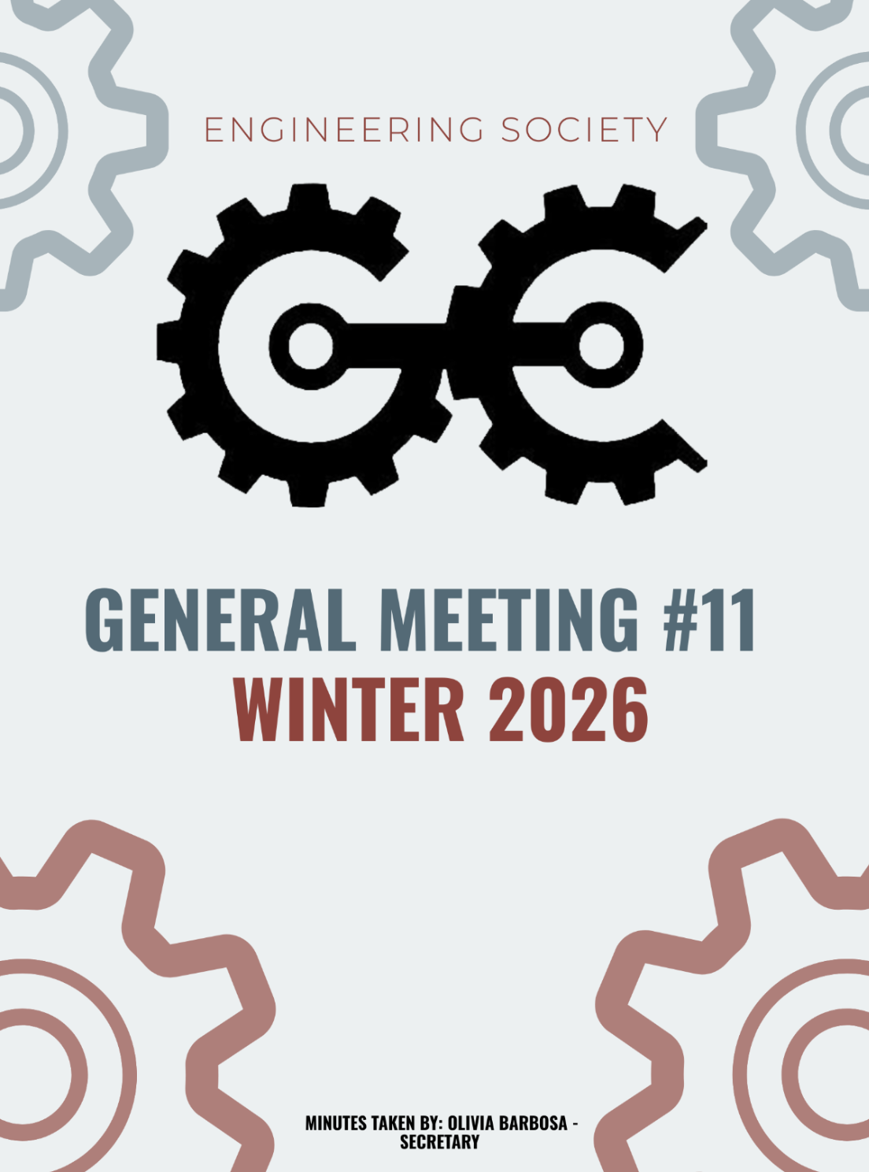11th GENERAL MEEETING
JANURARY 13th , 2026, 7:00 PM
UNIVERSITY OF GUELPH, THRN 1365
ATTENDANCE
NAME | ROLE | PRESENT
PHILLIP MCMORRAN | PRESIDENT | Y
CHARLES KOSHMAN | CHAIR | Y
OLIVIA BARBOSA | SECRETARY (W) | Y
GIULIA CASTI | THRN MANAGER | Y
SABINE HAMZE | VP EXTERNAL | Y
JOSEPH HOWELL | VP ACADEMIC | Y
VERONICA LYNAS | VP SOCIAL | Y
SUSANNA PILCHAK | VP SOCIAL | Y
ABIGAIL JACKSON | VP COMMUNICATION | Y
ANDREA RODIN | VP EDI | N
QUY AN NGO (WILL) | VP FINANCE | . Y
NICHOLAS HUTZOL | VP INTERNAL | Y
LAINE YOUNG | 4TH YEAR ENVIRO/WATER REP | Y
SYDNEY YOTT | 4TH BIO/BIOMED REP | Y
HANNAH SMYTH-LIU | 4TH YEAR MECH REP | Y
EMMA RENAUD | 4TH YEAR BIO/BIOMED REP (F) | Y
STEVEN SHELESTOWSKY | 4TH YEAR COMP/ES&C REP | Y
MAGGIE MALKOSKE | 3RD YEAR ENVIRO/WATER REP | Y
OJASWIN AUJLA | 3RD YEAR BIO/BIOMED REP | Y
URIEL MATAN MARKS-MAISTER | 3RD YEAR MECH REPRESENTATIVE | N
ERIC PFOHL | 2ND YEAR REP | Y
MAXIME MORIN | 2ND YEAR REP | Y
MAYA MURGELAS | 1ST YEAR REP | Y
MOHAMMED AL-ODA | 1ST YEAR REP | Y
KHANG NGUYEN | EEL MANAGER | N
SALIM DA’AS | EEL MANAGER | N
HANA RAVE | MERCH COORDINATOR | Y
EMMA SANDERSON | MERCH COORDINATOR | Y
OLIVIA JESSOP | ARTS OFFICER | N
MACY JOHNSTON | ATHLETICS COORDINATOR (F) | N
MAYA BARBERA | ATHLETICS COORDINATOR (W) | Y
ELAINE XU | GEPD CO-PRES | N
NIKITA UPADHYAY | GEPD CO-PRES | N
CELINE RUDOLPH | SPECIAL EVENTS COORDINATOR | Y
ANISH G. | SPECIAL EVENTS COORD | N
SAMANTHA CHCOSKI | SUSTAINABILITY COORDINATOR | Y
VANESSA BRENDERS | SUSTAINABILITY OFFICER | Y
HERMAN SAINI | MARKETING COORDINATOR (W) | Y
FRANKLIN G. | O-SNAP COORDINATOR | N
TARYNN KEARNEY | IT COORDINATOR | Y
SEBASTIEN PAUL | INTERNATIONAL REP | Y

LAND ACKNOWLEDGEMENT GIVEN BY PHIL

INTRODUCTIONS
- Welcomed new faces to the meeting.
- Everyone introduced themselves, sharing their name, position, program and year, pronouns, and fun fact.

OFFICE HOURS ACCOUNTABILITY

Presented by: Giulia
- Ongoing issue with members missing scheduled office hours without attempting to ask for cover
- Accountability measures being implemented:
  - Accountability postings will be displayed inside the EngSoc office only
  - Show up to two consecutive office hours to have photo removed
BUDGET MEETING
Presented by: Phil, added by Will
- Budget and reimbursement form to be distributed at the January 19 meeting.
- Teams reminded to update expense columns to reflect actual spending.
CEFES MEMBERSHIP FEE
Presented by: Sabine Hamze
- Membership fee structure revised to a tiered per‑student rate.
    - 65 ¢: 1000
    - 60 ¢: 1000-2000
    - 55 ¢: 2000-3000
    - 50 ¢: 3000+
- Current payment total: approximately $1,700.
CLOTHING DRIVE
Presented by: Tarynn
- Proposed idea of Engsoc to organize a clothing drive.
- Coordination to occur with VP EDI (Andrea).
PRINTER UPDATE
Presented by: Tarynn
- Initial concern raised regarding non‑functional printer.
- Issue resolved by plugging in the HDMI cable.
- Printer requires manual setup for printing.
- No immediate replacement required.
WELLNESS LOUNGE
Presented by: OJ
- Wellness Lounge closed as of Tuesday, January 13, 2026 due to ongoing noise concerns.
- Next steps: reach out to Susanna upon their return.
O-WEEK IMPROVEMENTS & FIRST-YEAR EXPERIENCE
Presented by: OJ
- Motion: Suspend meeting minutes for discussion.
Moved by: Abby
Seconded by: Steven
Vote: Passed unanimously (Phil abstained).

MEETING SUSPENDED

VOTE TO RESUME MEETING
- Motion: Vote to resume meeting
Moved by: Abby
Seconded by: Jo
Vote: Passed unanimously.

FIRST YEAR EXPERIENCE
Presented by: OJ
Discussion Summary:

Communicating with first years prior to first day of classes:
- OJ: Suggested using Mattucci to send a message via Courselink that includes info about Engsoc and O-week events.
- Steven: Clarified that Courselink does not open until the first day of classes.
- Abby (clarification): Noted that early Courselink access could be possible if coordinated with IT.
- Maya: Suggested utilizing the Quad: School of Engineering course to promote O-week and first year engagement.

Structure of Big Buddy program & O-Week operations:
- General consensus that additional structure is needed for the Big Buddy program and O-week execution.
- Members suggested increased involvement from Engsoc members and clearer group organizations to improve flow and engagement.
- Phil: Supported assigning group numbers at the merch line and noted that structured group separation should be included in transition documents. Raised the idea of a formal O-week committee at the ASGM.
- Abby: Recommended directing students to central locations (e.g. “come to the atrium”) rather than individual teams.
- Celine: Noted that students often tend to stick with friends when forming groups.
- Discussion included the possibility of having a dedicated O-week coordinator under VP Social to improve organization.
- Suggestions were made to extend Big Buddy engagement beyond O-Week committee to maintain student involvement throughout the year.
- Hannah: Shared that other schools have a dedicated O-Week committee and emphasized that gradual, realistic improvements year over year are most effective.
- Giulia: Reflected that past O-Week experiences felt more like coffee chats and were not strongly tailored to meeting new people.
- Ronnie: O-Week feedback and suggestions remain open to VP Socials.

Compliance with Student Experience Policies:
- Giulia: Mentioned that “purpling” has been proposed in previous years and believes it should be continued.
- Suzi: Noted that purpling has been viewed as hazing in the past, with Engsoc previously facing issues as a result, advised prioritizing compliance.
- Phil: Emphasized the importance of maintaining a positive relationship with Student Experience, highlighting that hazing is strictly prohibited.
- It was noted that Student Experience does not permit carpooling or bus pooling events due to insurance and off-campus restrictions.
- Phil: Suggested running fewer O-Week events with a focus on quality over quantity.
- Suzi: Added that Student Experience policies have changed significantly in recent years, reinforcing the need for continued discussion with policy limitations.
- OJ: Suggested that purpling could instead take place at events such as Corn Roast or Homecoming.

PARKING LOT
Sydney:
- Medical Innovation Tour: Proposal for a Biomed focused tour to include organized transportation
  - Transportation quote $621 for day
- Lunch will be provided by the company
- Fee of $5 to encourage attendance
- Event date: Jan 27
Vanessa:
- Sustainability checklist initiatives ongoing.
Ronnie:
- New Year’s Event: Volunteers needed; office hours promotion encouraged.
MOTION TO ADJOURN: MOVED BY PHIL
PASSED UNANIMOUSLY
MEETING ADJOURNED

NAME | ROLE | APPROVED
PHILIP MCMORRAN | PRESIDENT | Y
CHARLES KOSHMAN | CHAIR
OLIVIA BARBOSA | SECRETARY (W) | Y
GUILIA CASTI | THRN MANAGER | Y
SABINE HAMZE | VP EXTERNAL | Y
JOSEPH HOWELL | VP ACADEMIC | Y
VERONICA LYNAS | VP SOCIAL | Y
SUSANNA PILCHAK | VP SOCIAL | Y
ABIGAIL JACKSON | VP COMMUNICATION | Y
ANDREA RODIN | VP EDI | Y
QUY AN NGO (WILL) | VP FINANCE
NICHOLAS HUTZOL | VP INTERNAL | Y
LAINE YOUNG | 4TH YEAR ENVIRO/WATER REP | Y
SYDNEY YOTT | 4TH BIO/BIOMED REP | Y
HANNAH SMYTH-LIU | 4TH YEAR MECH REP | Y
EMMA RENAUD | 4TH YEAR BIO/BIOMED REP (F) | Y
STEVEN SHELESTOWSKY | 4TH YEAR COMP/ES&C REP | Y
MAGGIE MALKOSKE | 3RD YEAR ENVIRO/WATER REP
OJASWIN AUJLA | 3RD YEAR BIO/BIOMED REP | Y
URIEL MATAN MARKS-MAISTER | 3RD YEAR MECH REPRESENTATIVE
ERIC PFOHL | 2ND YEAR REP
MAXIME MORIN | 2ND YEAR REP
MAYA MURGELAS | 1ST YEAR REP | Y
MOHAMMED AL-ODA | 1ST YEAR REP | Y
KHANG NGUYEN | EEL MANAGER
SALIM DA’AS | EEL MANAGER
HANA RAVE | MERCH COORDINATOR
EMMA SANDERSON | MERCH COORDINATOR | Y
OLIVIA JESSOP | ARTS OFFICER | Y
MACY JOHNSTON | ATHLETICS COORDINATOR (F) | Y
MAYA BARBERA | ATHLETICS COORDINATOR (W) | Y
ELAINE XU | GEPD CO-PRES
NIKITA UPADHYAY | GEPD CO-PRES | Y
CELINE RUDOLPH | SPECIAL EVENTS COORDINATOR | Y
ANISH G. | SPECIAL EVENTS COORD | Y
SAMANTHA CHCOSKI | SUSTAINABILITY COORDINATOR | Y
VANESSA BRENDERS | SUSTAINABILITY OFFICER | Y
HERMAN SAINI | MARKETING COORDINATOR (W)
FRANKLIN G. | O-SNAP COORDINATOR
TARYNN KEARNEY | IT COORDINATOR
SEBASTIEN PAUL | INTERNATIONAL REP

