Look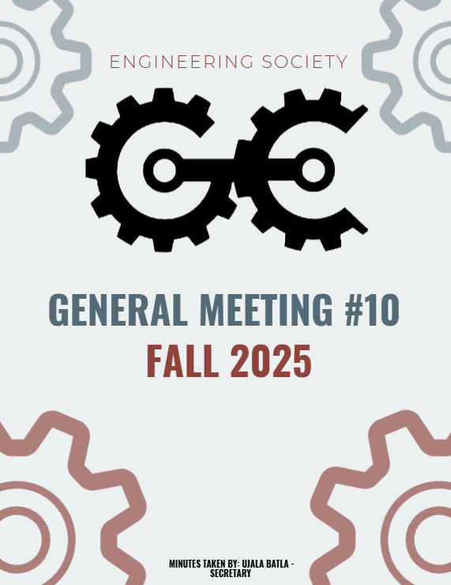

^{10th} GENERAL MEEETING
NOVEMBER 17th ,2025, 6:00 PM
UNIVERSITY OF GUELPH, THRN 1365

ATTENDANCE
NAME | ROLE | PRESENT
PHILLIP MCMORRAN | PRESIDENT | Y
CHARLES KOSHMAN | CHAIR | Y
UJALA BATLA | SECRETARY (F) | Y
GUILIA CASTI | SECRETARY (W)
SABINE HAMZE | VP EXTERNAL | Y
JOSEPH HOWELL | VP ACADEMIC | Y
VERONICA LYNAS | VP SOCIAL | Y
SUSANNA PILCHAK | VP SOCIAL | Y
ABIGAIL JACKSON | VP COMMUNICATION | Y
ANDREA RODIN | VP EDI | Y
QUY AN NGO (WILL) | VP FINANCE | . N
LAINE YOUNG | 4TH YEAR ENVIRO/WATER REP | Y
SYDNEY YOTT | 4TH BIO/BIOMED REP | N
NICHOLAS HUTZOL | THRN MANAGER | Y
KHANG NGUYEN | EEL MANAGER | N
SALIM DA’AS | EEL MANAGER
HANA RAVE | MERCH COORDINATOR (F)
EMMA SANDERSON | MERCH COORDINATOR (W) | N
OLIVIA JESSOP | ARTS OFFICER
MACY JOHNSTON | ATHLETICS COORDINATOR (F) | Y
HANNAH SMYTH-LIU | 4TH YEAR MECH REP
EMMA RENAUD | 4TH YEAR BIO/BIOMED REP (F) | Y
SOPHIA TOPERCZER | 3RD YEAR ENVIRO/WATER REP
OJASWIN AUJLA | 3RD YEAR BIO/BIOMED REP | Y
ELAINE XU | GEPD CO-PRES | Y
NIKITA UPADHYAY | GEPD CO-PRES
ERIC PFOHL | 2ND YEAR REP | Y
MAXIME MORIN | 2ND YEAR REP | Y
MAYA BARBERA | ATHLETICS COORDINATOR (W) | Y
MAYA MURGELAS | 1ST YEAR REP | Y
CELINE RUDOLPH | SPECIAL EVENTS COORDINATOR | Y
ANISH G. | SPECIAL EVENTS COORD | Y
HENRY TAIT | SUSTAINABILITY OFFICER (F)
VANESSA BRENDERS | SUSTAINABILITY OFFICER
LAUREN M. | MARKETING COORDINATOR (F) | Y
HERMAN SAINI | MARKETING COORDINATOR (W)
FRANKLIN G. | O-SNAP COORDINATOR
TARYNN KEARNEY | IT COORDINATOR | Y
 | COMP REPRESENTATIVE
URIEL MATAN MARKS-MAISTER | 3RD YEAR MECH REPRESENTATIVE | Y
ETHAN CARREON | TREASURER CG
MATTIGAN DILLABOUGH | PRODUCER CG
ABBY REDMOND | OWWA PRESIDENT
OWEN MACKENZIE | GNCTR CO-CAPTAIN
CARRYS FRANKLIN | GNCTR CO-CAPTAIN
SWAVA BANGALI | WISE
MARTINA BJURVAN | ESW
ANNA STERLING | ESW
STEVEN | IEEE
ELIJAH FERNANDES | IEEE / IT COORDINATOR | Y
MOHAMMED AL-ODA | 1ST YEAR REP | Y
STEVE | 4TH YEAR REP | Y
BAS | INTERNATIONAL REP | Y

LAND ACKNOWLEDGEMENT GIVEN BY EMMA

APPROVAL OF LAST WEEKS MEETING MINUTES
- Motion moved by Abby, seconded by Phil.
- Vote passed unanimously.

PHIL – BUDGET AMENDMENT FORO DEC 6TH MEMORIAL
- Proposal to increase rose costs from $120 → $300 to ensure sufficient funds.
- Motion moved by Abby, seconded by Nick.
- Vote passed unanimously with Phil abstaining.

OJ – WELLNESS ROOM UPDATE
- Proposal for one key card scanner for the door next to the stairs.
- Only Engineering students will have access.
- If someone lets in a non-Eng student, they are liable for any breaches.
- Double doors from EngSoc office will be exit-only.
- Campus Safety Updates:
- Students in the lounge for ~4 hours may be flagged (especially during exams).
- Panic buttons operate the same way as the yellow emergency poles.
- QR codes for reporting breaches to Campus Safety.
- Funding:
- Campus Safety grant application submitted.
- If unsuccessful, the Dean may cover remaining costs.
- Phil suggested rebranding the lounge as an “events centre” so other clubs can book it starting January.
- Jon Don expressed concern about whether the proposed physical controls fully address current issues.
- Phil noted the space will be safer and access can be restricted if needed.
- Worst-case scenario: wellness lounge will be out of commission starting January, which is manageable.

OJ – GUELPH ENGINEERING COMPETITION BUDGET AMENDMENT
- Prize money was $4050 (vs $4500 budgeted).
- Pizza and hospitality coffee cost less than expected.
- Total GEC cost is down $403.47, covered by the Academic Budget (Line 75).
- Phil motioned to remove repeated Line 75.
- Motion moved by Nick, seconded by Ronnie.
- Passed with Abby and Max abstaining.
- Motion to approve overall amended budget moved by Suzi, seconded by Steven.
- Vote passed with Abby and Max abstaining.

PARKING LOT
- Celine: Requested feedback regarding the “Ballin for a Cause” basketball charity event.

MOTION TO ADJOURN: MOVED BY NICK, SECONDED BY ABBY
PASSED UNANIMOUSLY
MEETING ADJOURNED

NAME | ROLE | APPROVED (Y/N)
PHILLIP MCMORRAN | PRESIDENT | Y
CHARLES KOSHMAN | CHAIR | Y
UJALA BATLA | SECRETARY (F)
GUILIA CASTI | THORN MANAGER | Y
SABINE HAMZE | VP EXTERNAL | Y
JOSEPH HOWELL | VP ACADEMIC | Y
VERONICA LYNAS | VP SOCIAL | Y
SUSANNA PILCHAK | VP SOCIAL | Y
ABIGAIL JACKSON | VP COMMUNICATION | Y
ANDREA RODIN | VP EDI
QUY AN NGO (WILL) | VP FINANCE
LAINE YOUNG | 4TH YEAR ENVIRO/WATER REP
SYDNEY YOTT | 4TH BIO/BIOMED REP | Y
NICHOLAS HUTZOL | THRN MANAGER | Y
KHANG NGUYEN | EEL MANAGER
SALIM DA’AS | EEL MANAGER
HANA RAVE | MERCH COORDINATOR (F)
EMMA SANDERSON | MERCH COORDINATOR (W)
OLIVIA JESSOP | ARTS OFFICER
MACY JOHNSTON | ATHLETICS COORDINATOR (F)
HANNAH SMYTH-LIU | 4TH YEAR MECH REP | Y
EMMA RENAUD | 4TH YEAR BIO/BIOMED REP (F) | Y
STEVEN SHELESTOWSKY | 4TH YEAR COMP/ES&C REP | Y
SOPHIA TOPERCZER | 3RD YEAR ENVIRO/WATER REP | Y
OJASWIN AUJLA | 3RD YEAR BIO/BIOMED REP | Y
ELAINE XU | GEPD CO-PRES
NIKITA UPADHYAY | GEPD CO-PRES | Y
ERIC PFOHL | 2ND YEAR REP | Y
MAXIME MORIN | 2ND YEAR REP | Y
MAYA BARBERA | ATHLETICS COORDINATOR (W)
CELINE RUDOLPH | SPECIAL EVENTS COORDINATOR
ANISH G. | SPECIAL EVENTS COORD
SAMRATH SINGH | 3RD YEAR REP
VANESSA BRENDERS | SUSTAINABILITY OFFICER | Y
LAUREN M. | MARKETING COORDINATOR (F) | Y
HERMAN SAINI | MARKETING COORDINATOR (W) | Y
FRANKLIN G. | O-SNAP COORDINATOR | Y
TARYNN KEARNEY | IT COMMISSIONER | Y
 | COMP REPRESENTATIVE
URIEL MATAN | 3RD YEAR MECH REPRESENTATIVE | Y
MAYA MURGELAS | 1ST YEAR REP | Y
Mohammed Al-Oda | 1ST YEAR REP | Y
JON DON | FACULTY ADVISOR
ELIJAH FERNANDES | IT COORDINATOR | Y

