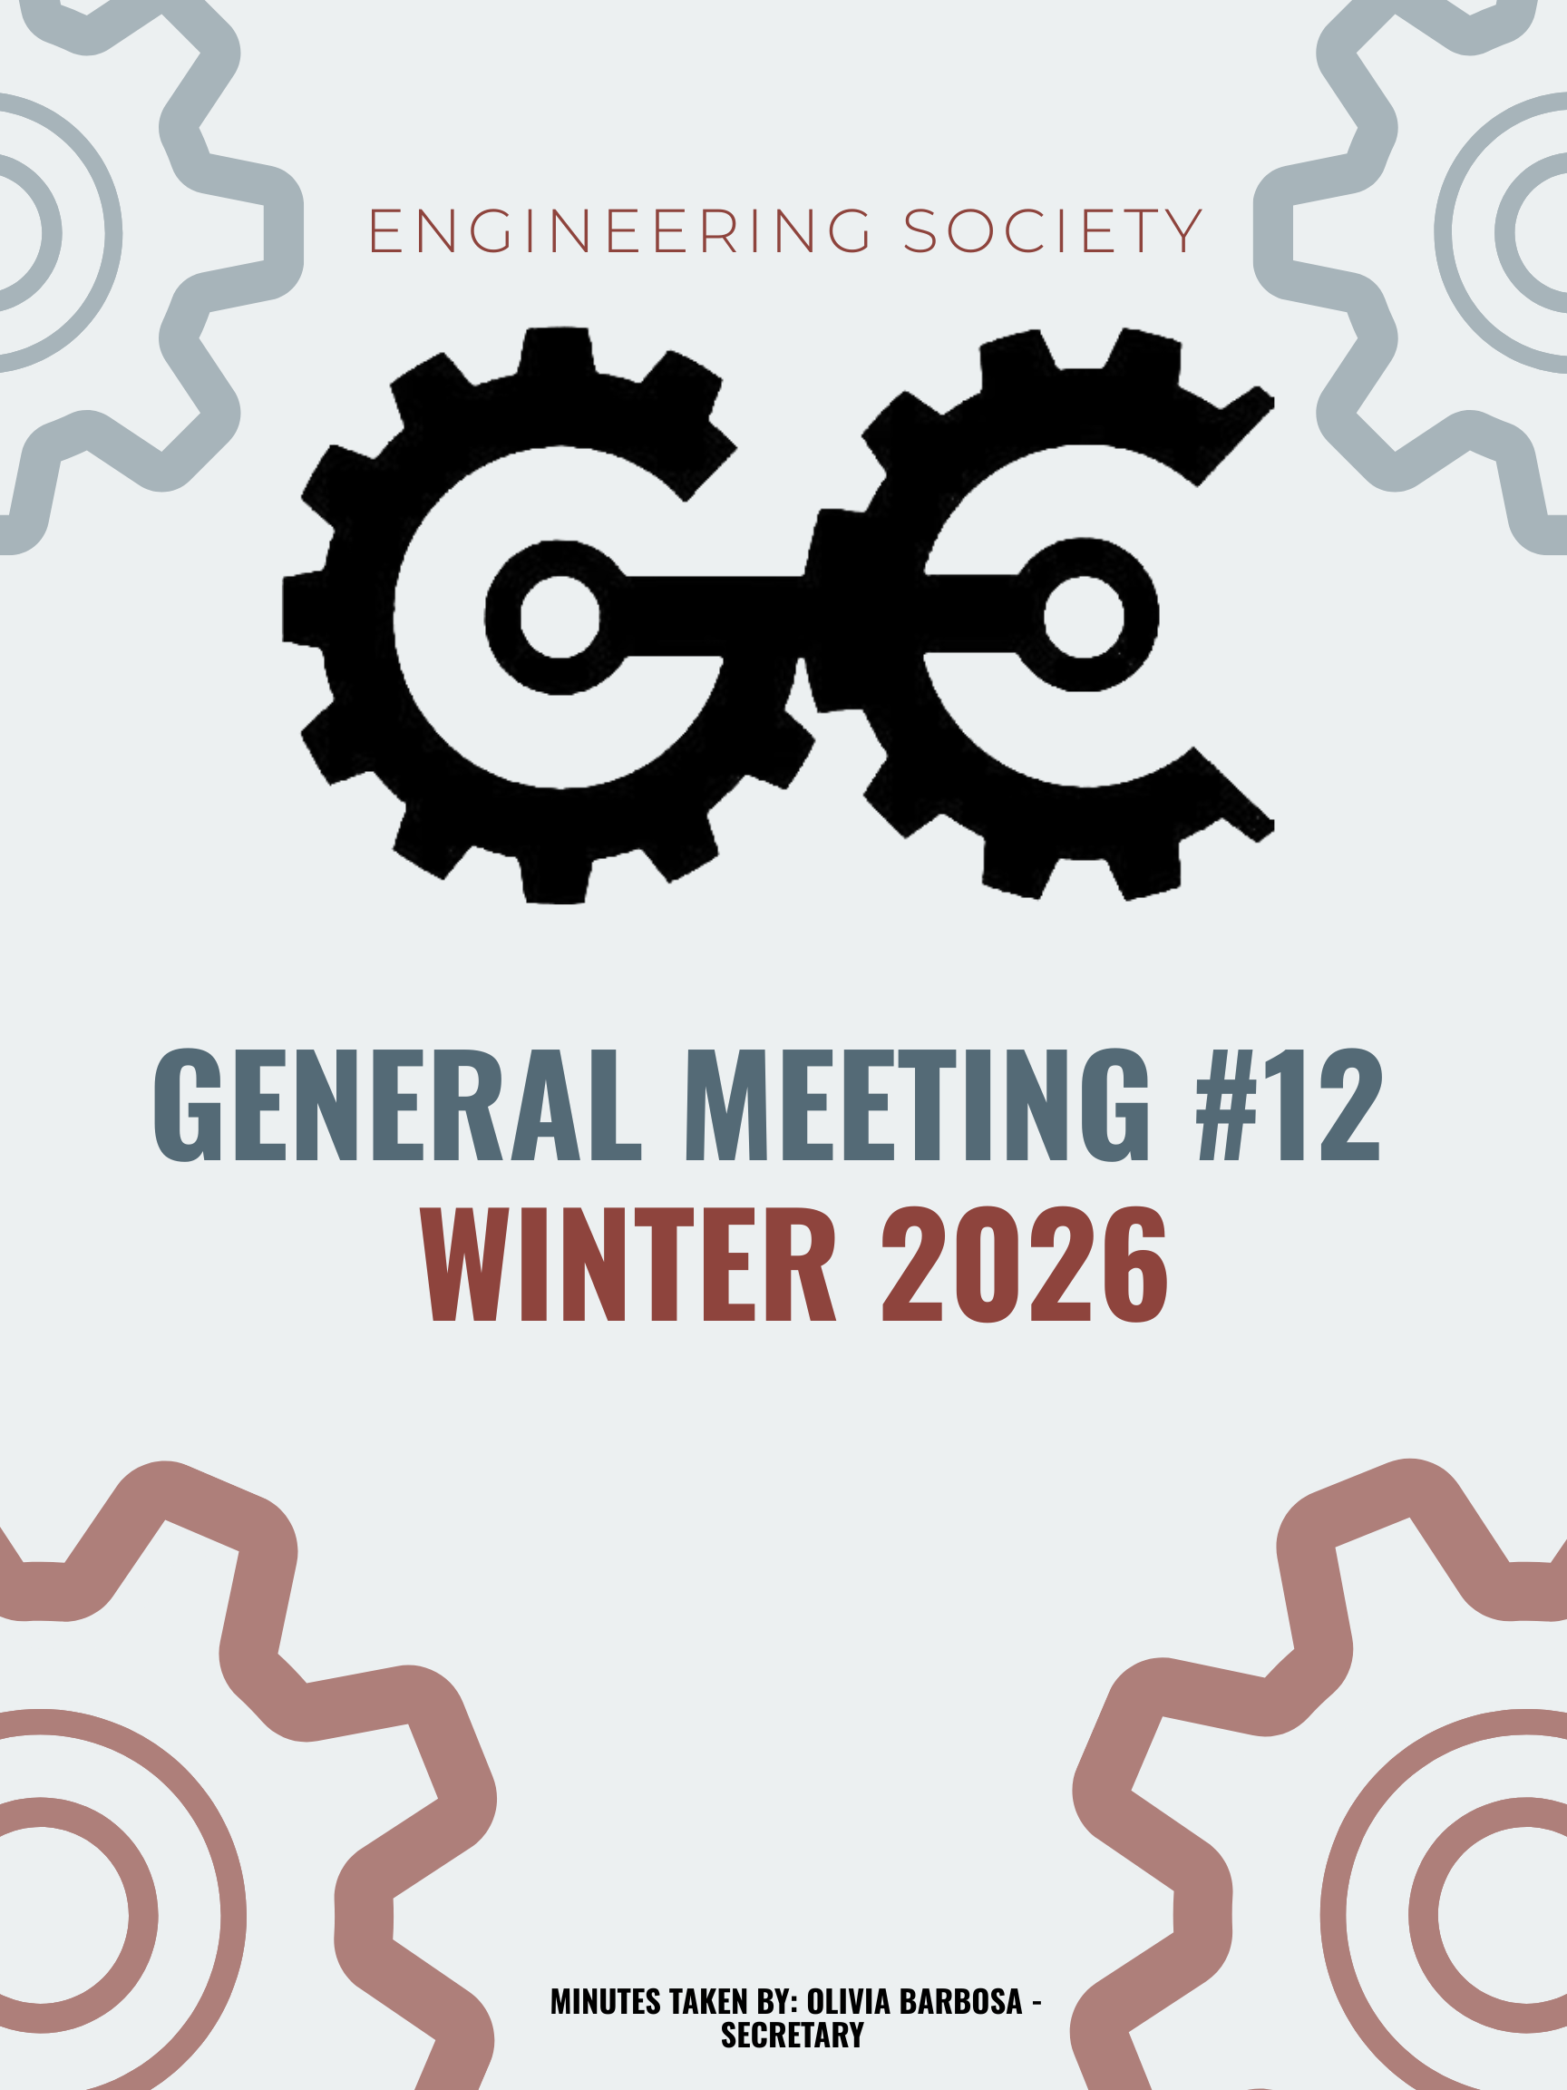
12th GENERAL MEEETING
JANURARY 19th, 2026, 6:00 PM
UNIVERSITY OF GUELPH, THRN 1365
ATTENDANCE
NAME | ROLE | PRESENT
PHILLIP MCMORRAN | PRESIDENT | Y
CHARLES KOSHMAN | CHAIR | N
OLIVIA BARBOSA | SECRETARY (W) | Y
GIULIA CASTI | THRN MANAGER | Y
SABINE HAMZE | VP EXTERNAL | Y
JOSEPH HOWELL | VP ACADEMIC | Y
VERONICA LYNAS | VP SOCIAL | Y
SUSANNA PILCHAK | VP SOCIAL | Y
ABIGAIL JACKSON | VP COMMUNICATION | Y
ANDREA RODIN | VP EDI | Y
QUY AN NGO (WILL) | VP FINANCE | . Y
NICHOLAS HUTZOL | VP INTERNAL | Y
LAINE YOUNG | 4TH YEAR ENVIRO/WATER REP | Y
SYDNEY YOTT | 4TH BIO/BIOMED REP | N
HANNAH SMYTH-LIU | 4TH YEAR MECH REP | N
EMMA RENAUD | 4TH YEAR BIO/BIOMED REP (F) | Y
STEVEN SHELESTOWSKY | 4TH YEAR COMP/ES&C REP | Y
MAGGIE MALKOSKE | 3RD YEAR ENVIRO/WATER REP | Y
OJASWIN AUJLA | 3RD YEAR BIO/BIOMED REP | Y
URIEL MATAN MARKS-MAISTER | 3RD YEAR MECH REPRESENTATIVE | N
ERIC PFOHL | 2ND YEAR REP | Y
MAXIME MORIN | 2ND YEAR REP | Y
MAYA MURGELAS | 1ST YEAR REP | N
MOHAMMED AL-ODA | 1ST YEAR REP | Y
KHANG NGUYEN | EEL MANAGER | Y
SALIM DA’AS | EEL MANAGER | Y
HANA RAVE | MERCH COORDINATOR | N
EMMA SANDERSON | MERCH COORDINATOR | Y
OLIVIA JESSOP | ARTS OFFICER | N
MACY JOHNSTON | ATHLETICS COORDINATOR (F) | N
MAYA BARBERA | ATHLETICS COORDINATOR (W) | Y
CELINE RUDOLPH | SPECIAL EVENTS COORDINATOR | Y
ANISH G. | SPECIAL EVENTS COORD | Y
SAMANTHA CHCOSKI | SUSTAINABILITY COORDINATOR | Y
VANESSA BRENDERS | SUSTAINABILITY OFFICER | Y
HERMAN SAINI | MARKETING COORDINATOR (W) | N
FRANKLIN G. | O-SNAP COORDINATOR | Y
TARYNN KEARNEY | IT COORDINATOR | N
SEBASTIEN PAUL | INTERNATIONAL REP | Y

LAND ACKNOWLEDGEMTN GIVEN BY EMMA SANDERSON

APPROVAL OF LAST WEEKS MEETING MINUTES
- Motion: Approve last week’s meeting minutes.
  - Moved by: Abby
  - Seconded by: Suzi
  - Vote: Passed unanimously (Phil abstained)
VP ACADEMIC BUDGET
Presented by: Nick
- $215 allocated for townhall pizza.
- Motion: Approve VP Academic budget.
  - Moved by: Abby
  - Seconded by: Ronnie
  - Vote: Passed unanimously (Phil & Will abstain)

VP EXTERNAL BUDGET
Presented by: Sabine
- Delegate fees for several conferences, including CALE (day passes included), ESSCO, CFES, CEC, and OAC.
- Transportation costs reimbursed.
- Allocated merch to be distributed at CALE.
- Motion: Approve VP External Budget.
  - Moved by: Abby
  - Seconded by: Nick
  - Vote: Passed unanimously (Sabine, Will & Phil abstain)

VP INTERNAL BUDGET
Presented by: Nick
- $250 allocated for SAGM.
- Motion: Approve VP Internal Budget.
  - Moved by: Abby
  - Seconded by: Ronnie
  - Vote: Passed unanimously (Phil, Will, and Nick abstain)

BUDGET VP SOCIALS
Presented by: Suzi and Ronnie
- Reviewed budget for Fake NYE (paid), Basketball Tournament, and Banquet.
- Motion: Approve VP Socials Budget.
  - Moved by: Abby
  - Seconded by: Sabine
  - Vote: Passed unanimously (Will, Phil, Suzi, Ronnie abstain)

VP EDI BUDGET
Presented by: Andrea
- Expenses for Food Drive, Donation Fund, snacks for EDI Circle events, and snacks and supplies for international student rep event.
- Motion: Approve VP EDI Budget.
  - Moved by: Abby
  - Seconded by: Sabine
  - Vote: Passed unanimously. (Will, Phil, Andrea abstain)

BUDGET MERCH OFFICER BUDGET
Presented by: Emma Sanderson
- Items discussed: Scarves, Shot Glasses, Patches, and supplies for merch table.
- Motion: Approve Merch Officer Budget.
  - Moved by: Nick
  - Seconded by: Max
  - Vote: Passed unanimously (Phil & Will abstain)

ARTS OFFICER BUDGET
Presented by: Suzi
- Expenses for Stich * B***h, Candygrams, and Poster Making.
- Motion: Approve Arts Officer Budget.
  - Moved by: Abby
  - Seconded by: Sabine
  - Vote: Passed unanimously (Will, Phil, Suzi & Ronnie abstain)

THORN MANAGER BUDGET
Presented by: Giulia
- Expenses for coat rack, garbage and recycling bins, fridge and vacuum.
- Motion: Approve Thorn Manager Budget.
  - Moved by: Sabine
  - Seconded by: Nick
- Budget line 71 removed.
- Motion: Approve amended Thorn Manager Budget.
  - Moved by: Nick
  - Seconded by: Abby
  - Vote: Passed unanimously (Will, Phil & Nick abstain)

EEL MANAGER BUDGET
Presented by: Khang and Salim
- Expenses for MyTurn Subscription fee.
- Motion: To approve EEL Manager Budget.
  - Moved by: Abby
  - Seconded by: Suzi
  - Vote: Passed unanimously (Phil, Will & Nick abstain)

ATHLETIC BUDGET
Presented by: Maya
- Clarification made by Phil to revise line 86 from “insurance” to “cancellation fee”.
- Motion: Approve Athletic Budget.
  - Moved by: Abby
  - Seconded by: Alex
  - Vote: Passed unanimously (Phil, Will, Suzi & Ronnie abstain)

SPECIAL COORDINATOR BUDGET
Presented by: Anish and Celine
- Expenses towards Charity Basketball Event, patches for Charity event, and the Relay for Life Event.
- Motion: Approve Special Coordinator Budget.
  - Moved by: Abby
  - Seconded by: Ronnie
  - Vote: Passed unanimously (Phil, will, Suzi & Ronnie abstain)

O’SNAP COORDINATOR BUDGET
Presented by: Frank
- Motion: Approve O’Snap Budget.
  - Moved by: Sabine
  - Seconded by: Abby
- Amendment to add an “Expected Revenue” item on line 100.
- Motion: Approve amended O’Snap Budget.
  - Moved by: Abby
  - Seconded by: Sabine
  - Vote: Passed unanimously (Phil, Abby & Will abstained)

1ST YEAR REP BUDGET
Presented by: Mo
- Expenses towards EngPub event.
- Motion: Approve 1st Year Rep Budget.
  - Moved by: Abby
  - Seconded by: Emma
  - Vote: Passed unanimously (Phil & Will abstain)

2ND YEAR REP BUDGET
Presenter: Max and Eric
- Expenses for second year socials.
- Motion: Approve 2nd Year Rep Budget.
  - Moved by: Abby
  - Seconded by: Sabine
- Motion: Approve amended 2nd Year Rep Budget.
- Amendment to separate the budget into two line items for the two events and exclude funds from the previous semester.
  - Moved by: Sabine
  - Seconded by: Ronnie
  - Vote: Passed unanimously (Phil, Will, Eric & Max abstain).
3RD YEAR REP BUDGET
Presented by: Alex
- Expenses for third year social event.
- Motion: Approve 3rd Year Rep Budget.
  - Moved by: Abby
  - Seconded by: Emma
- Amendment to exclude funds from the previous semester.
- Motion: Approve amended 3rd year rep budget.
  - Moved by: Abby
  - Seconded by: Sabine
  - Vote: Passed unanimously (Will, Phil & Alex abstain)

4TH YEAR REP BUDGET
Presented by: Emma Renaud
- Expenses towards Iron Ring Party and MIX GEPD Event.
- Motion: Approve 4th year rep Budget.
  - Moved by: Sabine
  - Seconded by: Suzi
  - Vote: Passed unanimously (Phil, Will & Emma abstain)

SUSTAINABILITY BUDGET
Presented by: Vanessa
- $30 allocated for Sustainability Contest.
- Motion: Approve Sustainability Budget.
  - Moved by: Abby
  - Seconded by: Max
  - Vote: Passed unanimously (Will, Phil & Andrea abstain)
MOTION TO ADJOURN: MOVED BY NICK
SECONDED BY: LAINE
PASSED UNANIMOUSLY
MEETING ADJOURNED

NAME | ROLE | APPROVED
PHILIP MCMORRAN | PRESIDENT
CHARLES KOSHMAN | CHAIR
OLIVIA BARBOSA | SECRETARY (W) | Y
GUILIA CASTI | THRN MANAGER | Y
SABINE HAMZE | VP EXTERNAL | Y
JOSEPH HOWELL | VP ACADEMIC | Y
VERONICA LYNAS | VP SOCIAL | Y
SUSANNA PILCHAK | VP SOCIAL | Y
ABIGAIL JACKSON | VP COMMUNICATION | Y
ANDREA RODIN | VP EDI
QUY AN NGO (WILL) | VP FINANCE
NICHOLAS HUTZOL | VP INTERNAL | Y
LAINE YOUNG | 4TH YEAR ENVIRO/WATER REP | Y
SYDNEY YOTT | 4TH BIO/BIOMED REP | Y
HANNAH SMYTH-LIU | 4TH YEAR MECH REP | Y
EMMA RENAUD | 4TH YEAR BIO/BIOMED REP | Y
STEVEN SHELESTOWSKY | 4TH YEAR COMP/ES&C REP | Y
MAGGIE MALKOSKE | 3RD YEAR ENVIRO/WATER REP
OJASWIN AUJLA | 3RD YEAR BIO/BIOMED REP | N/A
URIEL MATAN MARKS-MAISTER | 3RD YEAR MECH REPRESENTATIVE | N/A
ERIC PFOHL | 2ND YEAR REP
MAXIME MORIN | 2ND YEAR REP
MAYA MURGELAS | 1ST YEAR REP
MOHAMMED AL-ODA | 1ST YEAR REP
KHANG NGUYEN | EEL MANAGER
SALIM DA’AS | EEL MANAGER
HANA RAVE | MERCH COORDINATOR | Y
EMMA SANDERSON | MERCH COORDINATOR | Y
OLIVIA JESSOP | ARTS OFFICER
MACY JOHNSTON | ATHLETICS COORDINATOR (F)
MAYA BARBERA | ATHLETICS COORDINATOR (W)
ELAINE XU | GEPD CO-PRES | Y
NIKITA UPADHYAY | GEPD CO-PRES
CELINE RUDOLPH | SPECIAL EVENTS COORDINATOR | Y
ANISH G. | SPECIAL EVENTS COORD
SAMANTHA CHCOSKI | SUSTAINABILITY COORDINATOR
VANESSA BRENDERS | SUSTAINABILITY OFFICER | Y
HERMAN SAINI | MARKETING COORDINATOR (W)
FRANKLIN G. | O-SNAP COORDINATOR
TARYNN KEARNEY | IT COORDINATOR | Y
SEBASTIEN PAUL | INTERNATIONAL REP

